**Athlete Tracking Project**

**Final Report**

**Prepared by Harun Yahya Ünal - 210706015**

There are three users for this website: Admin, Instructor, Student

First of all, you have to login the system.

There is a role section. You have to select the role that you want to log in with.

If you don’t have an account, you can create one by clicking on “Don’t have account” text.

There is a role selection in this page. There is space for you to enter additional information depending on the role you choose.

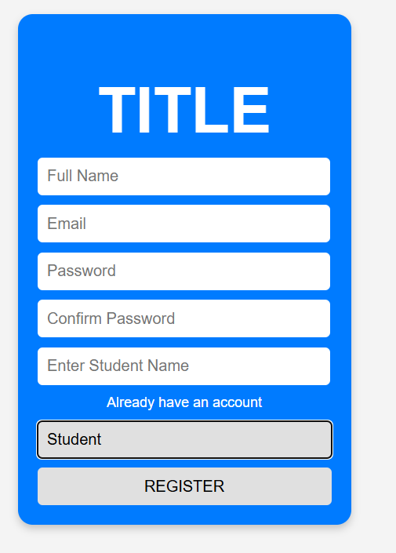

**For Student:**

There are six part (Sessions, MySessions, MyRecords, Instructors, Payment, UserInfo). Student can see all sessions in the session pages and can register to a session or cancel a session.

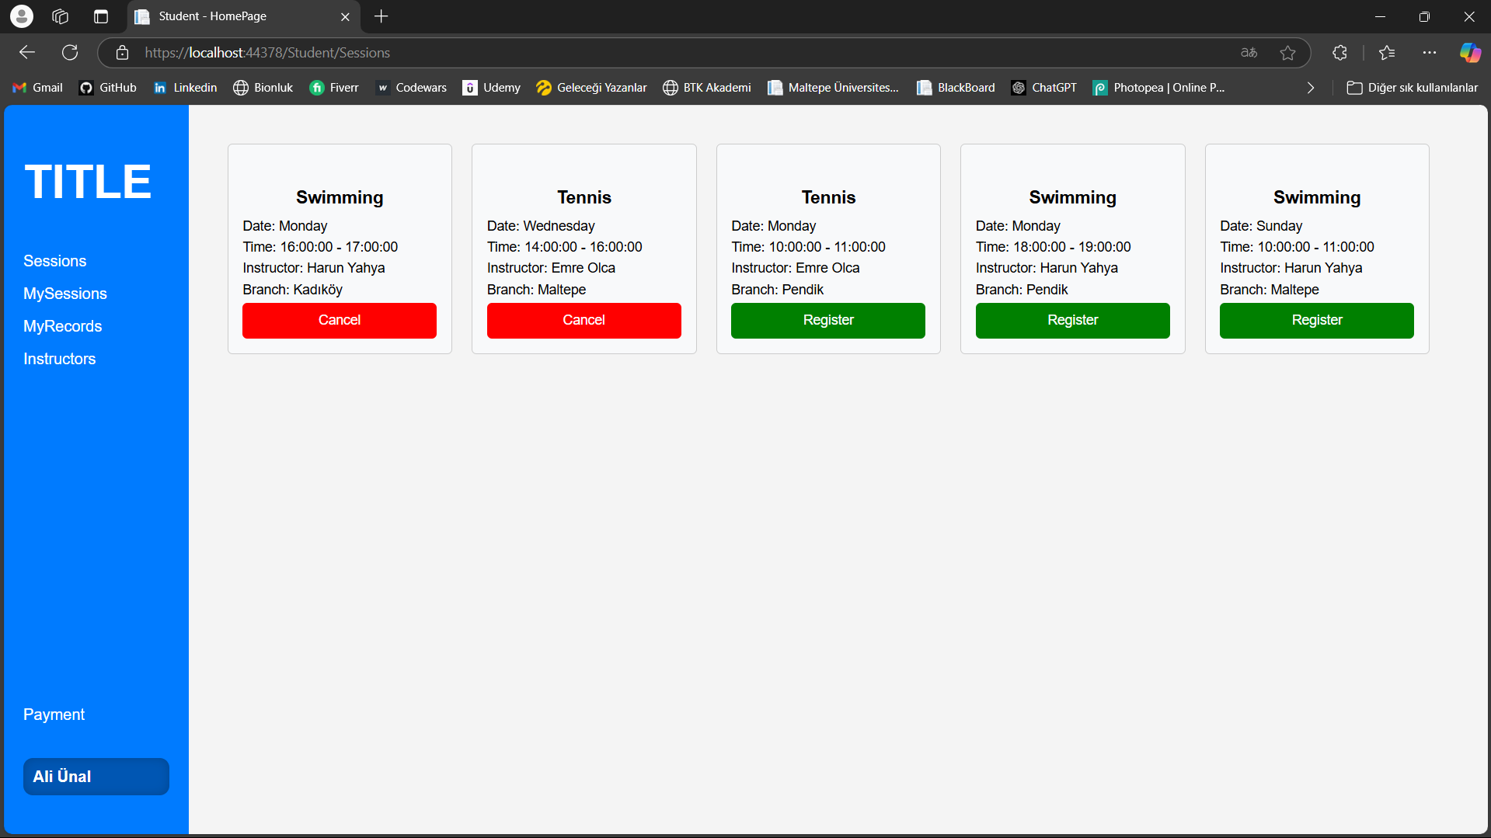

In mySession page student can only see the session he/she registered and cancel it.

In the MyRecords page student can see the growth records that entered by his/her instructor in a chart.

Student can manage the payment in the PaymentPage.

**For Instructor:**

There are three part (MySessions, MyStudents). Instructor can see all her/his sessions in the mySession pages and can add or cancel a session.

Instructor can see the students, add record for them in my students part.

Admin could not developed.